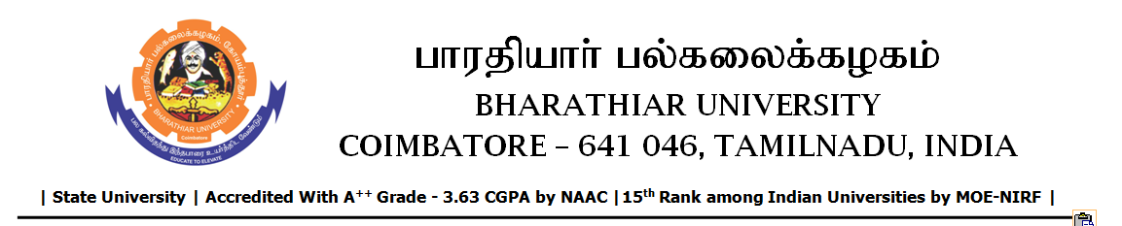

RE-TENDER INVITING NOTICE

e-Tender Notice No.BU/UE/AEE/25^{D}/D-1496/2025-2026 dated 09.03.2026

Online bid is invited through portal https://tntenders.gov.in from interested bidders upto 3.00 P.M on 17.03.2026 for the following work.
Sl. No | Name of Work | Estimate Amount (Approx.)  Rs. in lakhs | Period of Contract | EMD  Rs.
1 | Providing dispersion trench to the Gents hostel (Kambar, Elango, Sekhizhar and Thiruvalluvar) in Bharathiar University. | Rs.5.18 lakh | 4 Months | Rs.5180/-

UNIVERSITY ENGINEER

