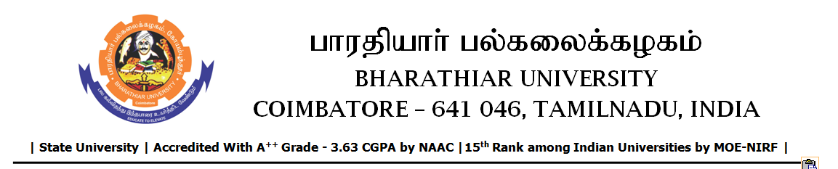
RE-TENDER INVITING NOTICE

e-Tender Notice No.BU/UE/AEE/32^{D}/D- 1494/2025-2026 dated 09.03.2026

Online bid is invited through portal https://tntenders.gov.in from interested bidders upto 3.00 P.M on 17.03.2026 for the following work.

Sl. No | Name of Work | Estimate Amount (Approx.)  Rs. in lakhs | Period of Contract | EMD  Rs.
1 | Special repair works to Kitchen, Dining hall and toilet block in the Vasuki hostel in Bharathiar University. | Rs.9.58 lakh | 5 Months | Rs.9,580/-

UNIVERSITY ENGINEER

