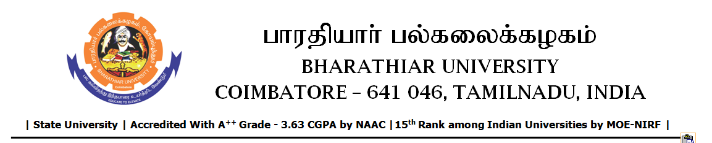

TENDER INVITING NOTICE

e-Tender Notice No.BU/UE/33^{D}/D-1422/2025-2026 dated 25.02.2026

Online bid is invited through portal https://tntenders.gov.infrom interested bidders upto 3.00 P.M on 12.03.2026 for the following work.

Sl. No | Name of Work | Estimate Amount (Approx.)  Rs. in lakhs | Period of Contract | EMD  Rs.
1 | Special repair works to toilet (East and West) side of Chellammal Hostel in Bharathiar University. | 5.42 | 5 Months | 5,420/-

