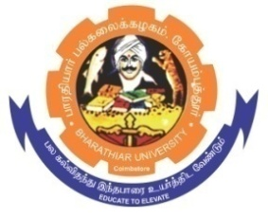
ghujpahh; gy;fiyf;fHfk;
BHARATHIAR UNIVERSITY
COIMBATORE – 641 046, TAMILNADU, INDIA

State University | Re-Accredited with “A++” Grade by NAAC | Ranked 46st among Indian Universities by MHRD-NIRF

e- TENDER INVITING NOTICE

E-Tender Notice No: BU/R-D8/2809/PSY-St.Almirah/2025-26 Date: 05.03.2026

Online Bids are invited through Tamil Nadu Government e-Procurement Portal website: www.tntenders.gov.in Tenders by Organisation Higher Education for the Purchase of 3 Nos. of Steel Almirah to the Department of Psychology, Bharathiar University, Coimbatore.
The Tender documents can be downloaded from 02.03.2026. Bid submission will be started on 02.03.2026 and will be closed on 17.03.2026

REGISTRAR

To
The Co-ordinator,
Centre for Internet & Website Services – with a request to upload the Tender Notice
Bharathiar University. in the University Website.

Copy to : 1. Finance Officer, BU.
2. The Professor & Head,
Dept. of Psychology, BU.

3. File Copy.

Website: www.b-u.ac.in E-Mail: regr@buc.edu.in Phone: 0422-2428108/2428126 Fax: +91 422 2425706

