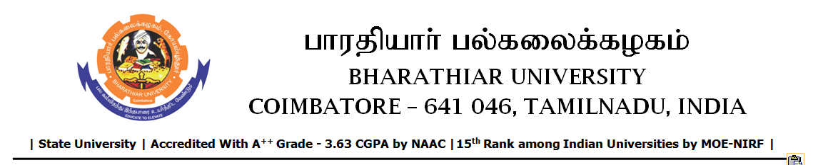
TENDER INVITING NOTICE

e–Tender Notice No.BU/UE/1^{D}/D- 217/2026-2027 dated 02.06.2026

Online bid is invited through portal https://tntenders.gov.in from interested bidders upto 3.00 P.M on 17.06.2026 for the following work.

Sl. No | Name of Work | Estimate Amount (Approx.)  Rs. in lakhs | Period of Contract | EMD  Rs.
1 | Special repair work of repairing and renewing the steel truss and false ceiling on the student work station in BSMED Bharathiar University. | Rs.4.26 lakh | 3 Months | Rs.4260/-

UNIVERSITY ENGINEER

