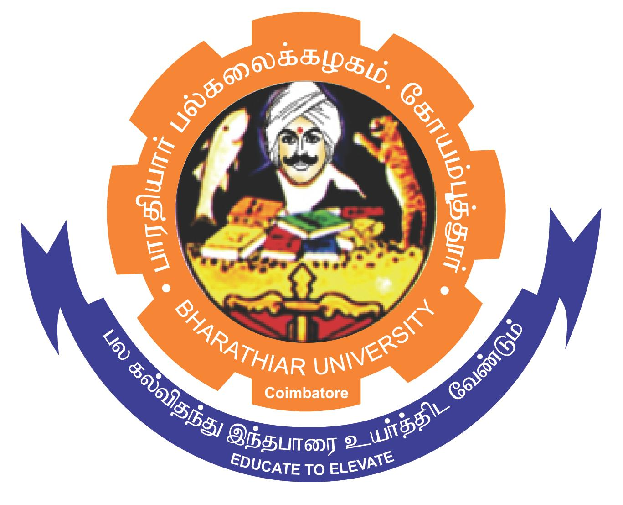
ghujpahh; gy;fiyf;fHfk;
BHARATHIAR UNIVERSITY
COIMBATORE – 641 046, TAMILNADU, INDIA

State University | Accredited with “A++” Grade by NAAC | Ranked 46th among Indian Universities by MoE-NIRF

e-TENDER NOTICE

E-Tender Notice No: BU/R-D1/15573/Chem &Glass/RC/2026-27 Date : 24.07.2026

Online bids are invited through Tamil Nadu Government e-procurement portal website www.tntenders.gov.in Tenders by Organization Higher Education for the purchase of Chemicals, Glasswares, Plasticwares & Laboratory Consumables to the various Science Departments/Centres of Bharathiar University, Coimbatore through Rate Contract.

REGISTRAR
TENDER INVITING AUTHORITY

To
The In-charge, Centre for Internet and Website Services, BU – with a request to host
the above in the University website.

Copy to :
- P.S. to The Vice-Chancellor, BU.
- P.A. to The Registrar, BU.
- The Finance Officer, BU.
- The HODs, Science Departments, BU.
- The Director – CRTD, DRDO, BU.
- The Co-ordinator, RUSA, BU.
- The In-charge, Centre for Internet and Website Services, BU – with a request to host the above in the University website.
- The Public Relation Officer, BU.

