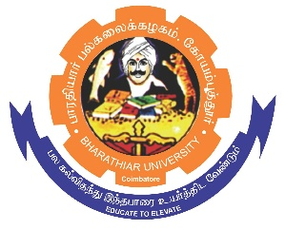
ghujpahh; gy;fiyf;fHfk;
BHARATHIAR UNIVERSITY
COIMBATORE – 641 046, TAMILNADU, INDIA

State University | Re-Accredited with “A++” Grade by NAAC | Ranked 46th among Indian Universities by MHRD-NIRF

e- TENDER INVITING NOTICE

E-Tender Notice No: BU/R-D8/Canteen/14195/2026-27 Date: 03.07.2026

Online bids are invited through portal https://tntenders.gov.in for Running canteen consisting of a Conventional style of Restaurant, Fruit shop, Chaat shop and counter to serve food items for one year from the date of Award of Contract in Bharathiar University Main campus.
The Tender documents
REGISTRAR

Website: www.b-u.ac.in E-Mail: regr@buc.edu.in Phone: 0422-2428108/2428126 Fax: +91 422 2425706

